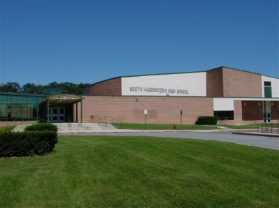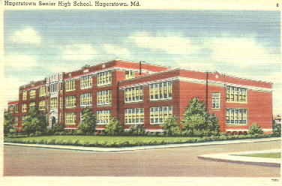

##### February 2014 Edition

***In Memorial***

* **Jone Lou Burket Bowman**

***February Birthdays***

**Dick Knode Norma Jean Hull Carl Gearhart Howard Rice**

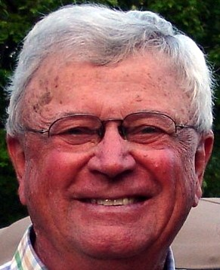 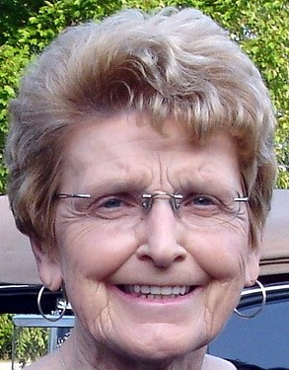 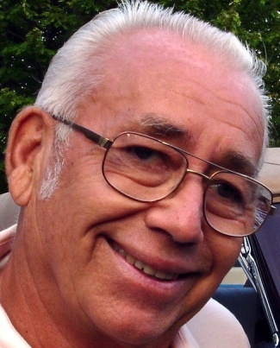 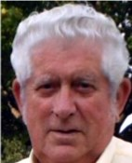

**Gordie Sanders Frit Hill Judy Iseminger Alice Lindsey**

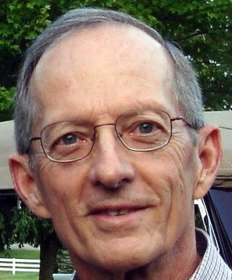 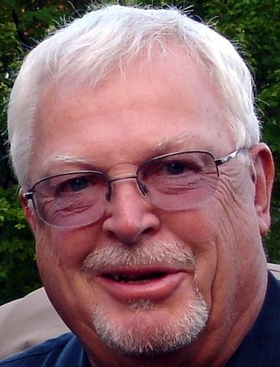 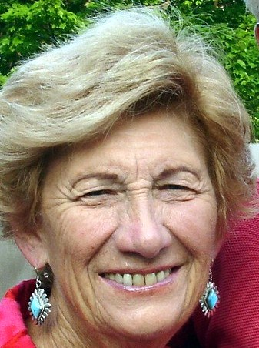 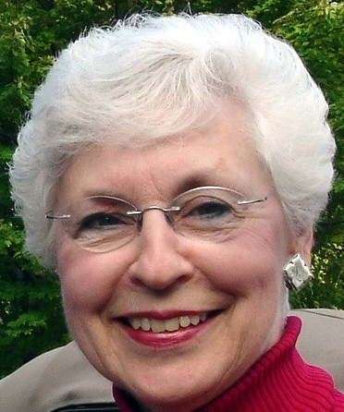 **Nancy Minnich Bob Moats Phil Brader Barbara Locke**

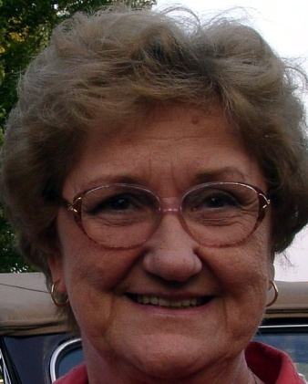 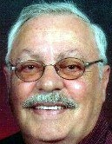  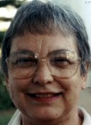

**Don Smith Elaine Finniff Judy Statler**

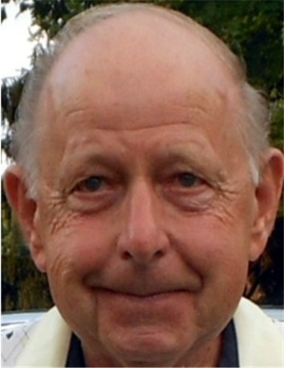 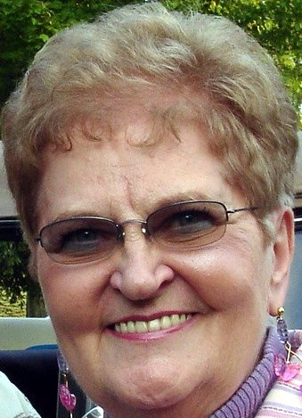 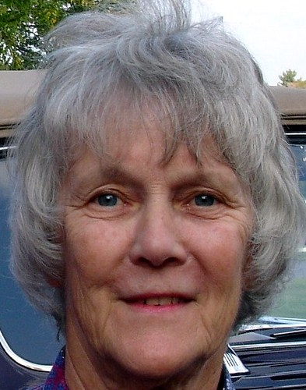

***February Anniversaries***

**Gene & Brenda Smith Arthur & Ann Corderman Helton**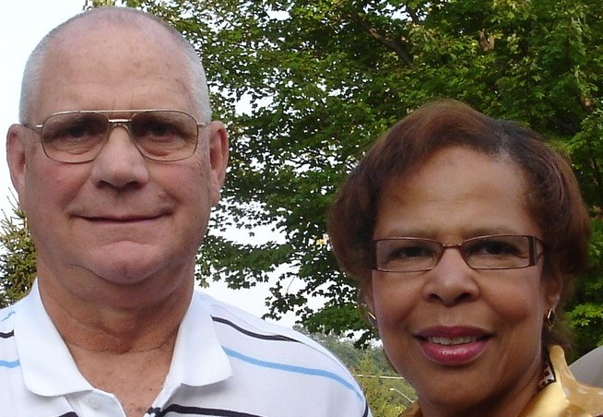 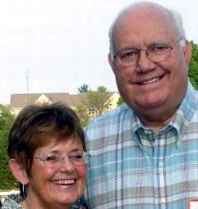

***Class Activities***

***Roger Kisel***

**I'm departing CONUS this Thursday, 16 January to go to Muscat, Oman.  I'll be there for two weeks teaching a Masters level class to 14 Omani MBA students, 11 of whom are women, in my capacity as an adjunct professor at Franklin University here in Columbus, OH.  I'll return home the end of January; then on 20 February, I'll return to Oman to teach a new group of 16 MBA students (6 of whom are women) an Operations Management class.  I'll be back home in New Albany, OH the 7th of March.**

***Gloria Bowers***

**Gloria’s husband, Richard Clem has published another document about the civil war.**

**If you are interested in reading the publication,** [**CLICK HERE**](COBLE%20ROCK.pdf)**.**

***Carole Smith***

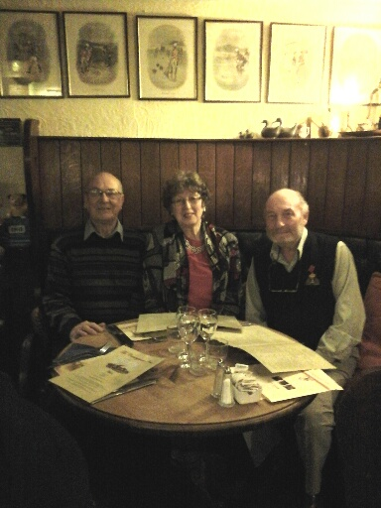

**L-R: Bernard (Bunny) Smith, Carole (Smith, no relation) Daly and Patrick (Paddy) Daly celebrate Christmas Eve at The Countryman in Shipley, West Sussex, UK.  Paddy later had two 80th birthday celebrations: one with family and another with his Old Suttonians Football Club.**

***Glenn Julian***

**Glenn published a family history document.** [**Click Here**](Glenn.pdf) **to view.**

***Bob Weller***

**As members of our class of ’57 pass on, it is important for us survivors to realize how special our class really is. For one thing, we appear to be two classes, SHHS Class of 1957 and NHHS Class of 1957. And this was the first time there had been a South Hagerstown High School and a North Hagerstown High School. Before that there was only Hagerstown High School, which we all attended. The reality is that, at least initially, in our hearts our two classes were really only one class – the 1957 class of Hagerstown High School. Indeed, I still wear my 1957 HHS class ring.**

**The creation of South Hagerstown High School (or South High as we called it) was a means of solving a political issue -- dealing with the need to help approach a human rights issue by integrating our public schools. We had heard of integrating schools, of course. The newspapers had stories about integration, and many of us read newspapers. I always checked the sports section and comics, and sometimes I even read some of the news stories. Many of these stories were negative and featured violence against our black citizens and actions such as governors, sheriffs, and other prominent persons vowing racial integration would never happen in their domains. Some even stated that God intended for the races to be separate. Maybe we (and our parents) were naïve. Like you, I grew up in a segregated town. I still remember the white lines on the city buses and the whites’ only drinking fountains in the public square. And I certainly did not realize the social and economic importance of having blacks and whites attend the same schools. Maybe that was the key to what happened – it didn’t seem like that big a deal. At any rate, the integration of public schools in Washington County was a very peaceful process – much unlike what happened in some other parts of Maryland. We had no race riots, no racially inspired fights, and very little name calling or ostracism. I don’t know about you, but I am proud of the peaceful way we integrated our schools and that I participated in that process. The biggest drawback to having two high schools was that we missed daily contact with our friends who went to the other school.**

**The interesting thing is that competition developed not between races but between North and South High. South High did not have a football team the first year. Mel Henry was the couch of the Hagerstown High football team, and a decision was made that he would stay on at North High and coach the Hagerstown High football team, with players from both schools on it, for one year. It was no coincidence that Terry Strock, an outstanding player, perhaps the best on the team, was a senior at South High and that by and large only South High seniors were on the combined 1957 football team. A different decision was made about basketball – each school would have its own basketball team from the very beginning.. The first time the two teams played each other was in the South High gym. I am certain the North High students showed up expecting a romp. They did not get it. Instead, they encountered a South High student body that even had its own song: “Are You from South High?” sung from the tune of “Are You from Dixie?” Many years later, I still remember this song and I have been quietly singing it as I write. By that time the game was over it was clear that we had developed a school identity and a fervid school spirit. So we started out as one class, were artificially put into two classes that ultimately became two real classes but with very close ties and friendships with members of the other class.**

**We were unique in other ways too. For one thing, we just preceded the baby boom (which started in 1942). This means we avoided most of the competition for classroom space and for jobs that followed. Underestimating the importance of this is very difficult. I mean, by the time we graduated and started applying for college admission, colleges were offering to pay us to attend. The U.S. government paid for my graduate school education and provided for basic living expenses. When we entered the job market, we had to produce, but the number of persons above us in the job hierarchy was relatively small, which made economic advancement quicker than would prove to be the case 10 years later.**

**And we were at the forefront of a revolution in gender identity. A slow fadeout with June Cleaver and a gradual entrance by Gloria Steinem and Betty Friedan. Although many of us had mothers who worked outside the home (mine worked at Fairchild Aircraft as a riveter), it was not viewed as the norm. Now it is. In fact, now not working outside the home is not the norm. And our mothers were in the forefront of the movement toward the redefinition of gender roles.**

**I am sure that there are many other ways in which our class is unique. I just want to point out to you that our class is unique and to give a few examples of why that is true. What happened to us did not happen to any other class in Hagerstown. We can feel good about ourselves as a class. I am proud to be a member of the first class of South High, 1957 and to have attended school with so many graduates of Hagerstown High and North High.**

***Ron Amos on Valentine’s Day***

1. **What was the most romantic thing you did on a Valentine’s Day?**

**Dinner with music and wine and sharing with Dotty and friends at Dollie’s Tea Room in Clearspring.**

1. **What was your most memorable Valentine’s Day?**

**The first one after my divorce.**

1. **What do you do to make Valentine’s Day special for your grandchildren?**

**Remembered them in my Last Will & Testament**

***Education Section***

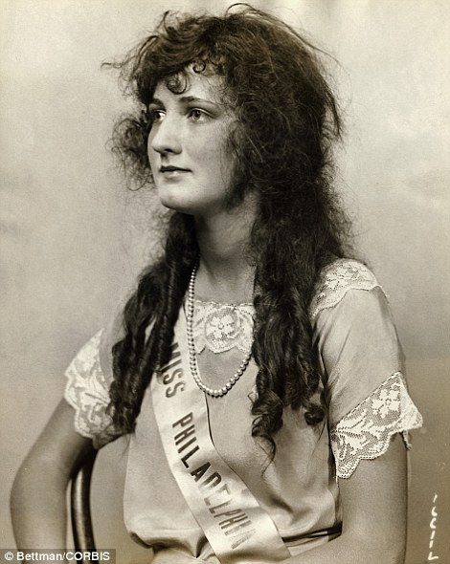 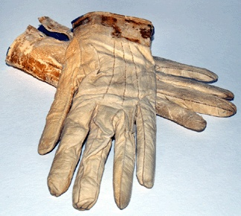

Miss America 1924 Leather gloves worn by Lincoln to Ford's Theater on the night of his assassination. Blood stains are visible at the cuffs.

[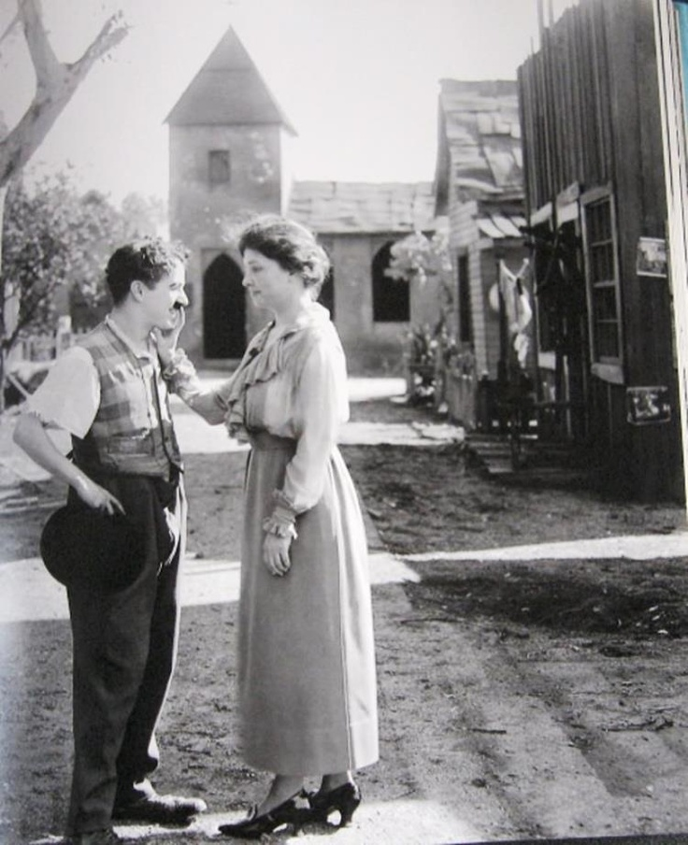](http://i.imgur.com/t97uADo.jpg) 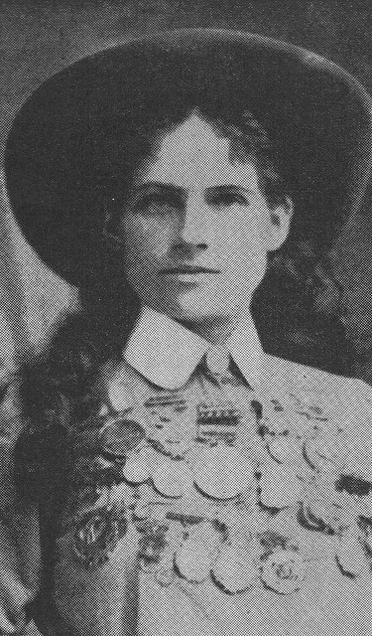

Helen Keller Meeting Charlie Chaplin Phoebe Mozee (aka: Annie Oakley).Famed for her marksmanship by 12 years old, she once shot the ashes off of Kaiser Wihelm II's cigarette at his invitation. When she outshot famed exhibition marksman Frank Butler, he fell in love with her and they married and remained married.

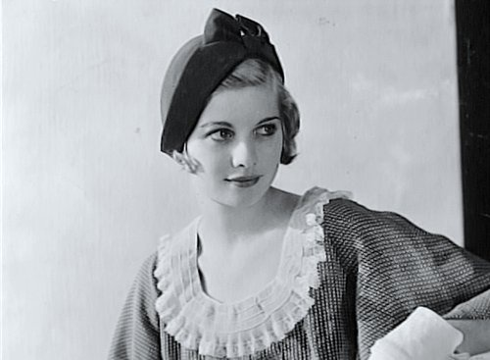 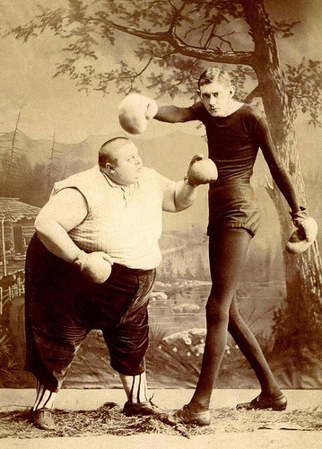

Very Young Lucy Lucille Ball around 1930 Two Victorian sideshow performers boxing - the fat man and the thin man.

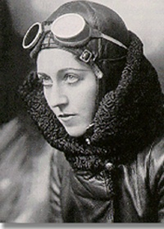

Amy Johnson, English aviator 1903-1941 One of the first women to gain a pilot's licence, Johnson won fame when she flew solo from Britain to Australia in 1930. Her dangerous flight took 17 days. Later she flew solo to India and Japan and became the first woman to fly across the Atlantic East to West, she volunteered to fly for The Women's Auxiialry Air Force in WW2, but her plane was shot down over the River Thames and she was killed.

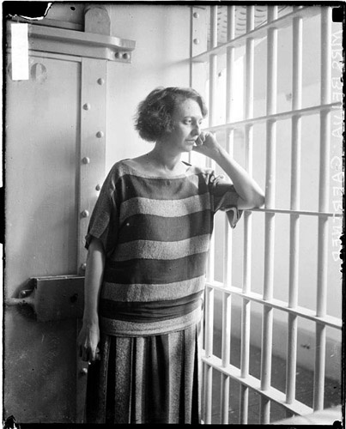 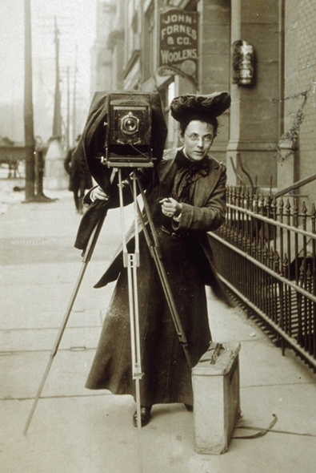

Prison Garb 1924. Belva Annan murderess Female photojournalist Jessie Tarbox on the whose trial records became the musical street with her camera, 1900s.

"Chicago."

[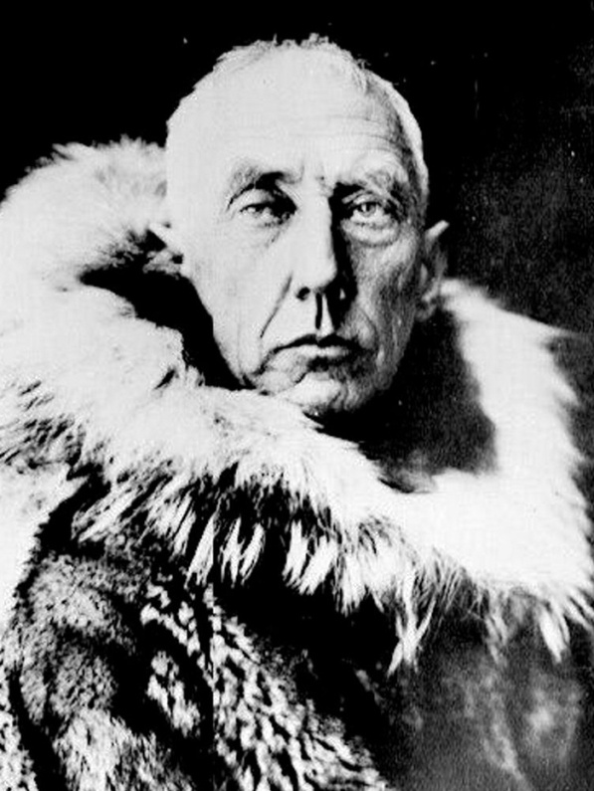](http://i.imgur.com/agkV2pq.jpg) 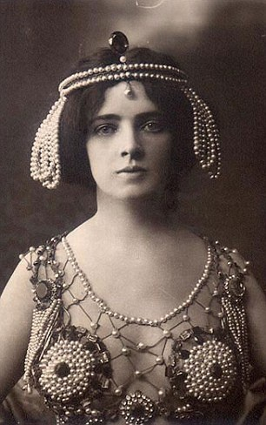

Roald Amundsen was the first person to South Pole. Seductive US dancing girl who was At approximately 3pm on December 14, 1911. sued for being too lewd, outed as a Amundsen raised the flag of Norway at lesbian, and fled London after beingthe South Pole and named the spot Polheim Pole Home London after being branded a German

spy who was sleeping with the prime

. minister's wife.

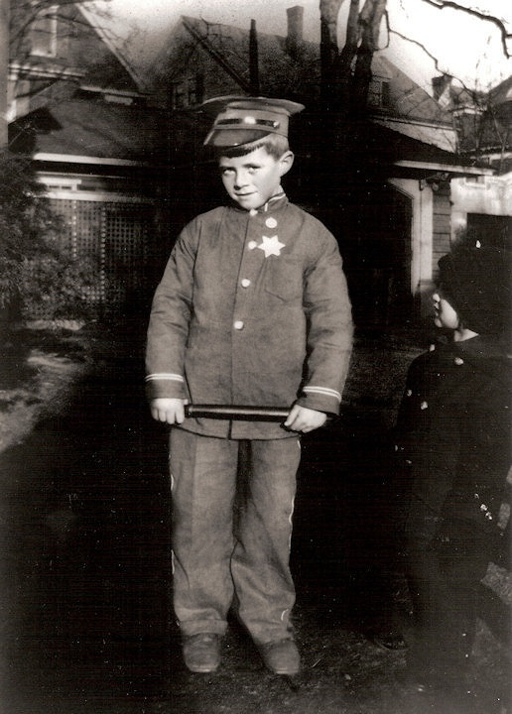 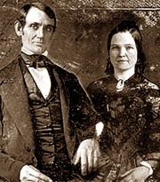

John Fitzgerald Kennedy Wedding day photograph of Abraham and Mary taken November 4, 1842 in Springfield,Illinois after three years of a stormy courtship and a broken engagement. Their love had endured.

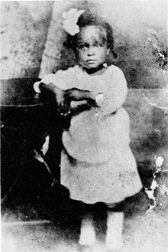 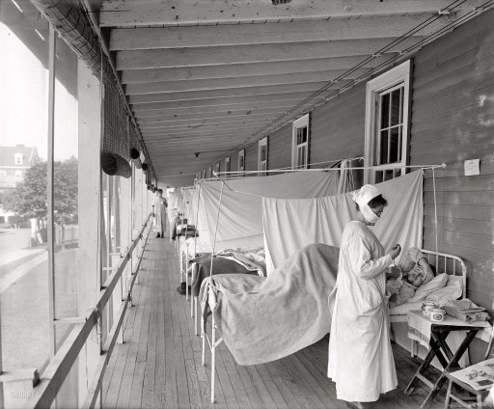

Billie Holiday at two years old, in 1917 Washington, D.C., circa 1919. "Walter Reed Hospital flu ward." One of the very few images in Washington-area photo archives documenting the influenza contagion of 1918-1919, which killed over 500,000 Americans and tens of millions around the globe. Most victims succumbed to bacterial pneumonia following influenza virus infection.

[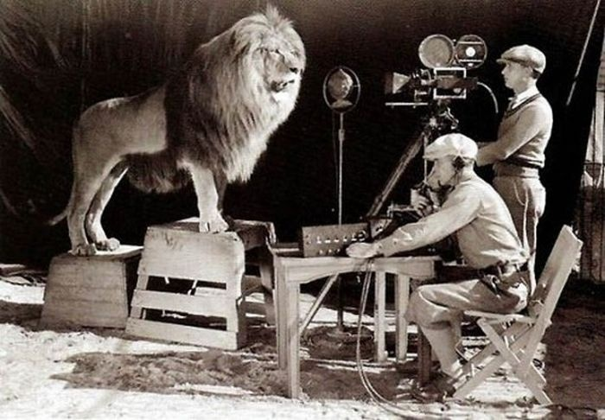](http://i.imgur.com/cK31m7l.jpg) 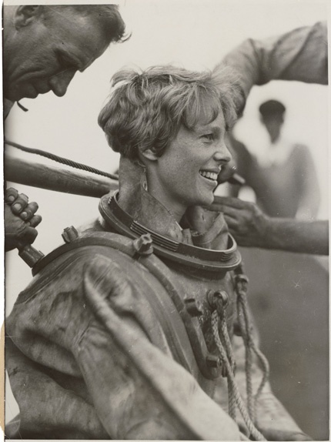

Filming the MGM Logo Amelia Earhart

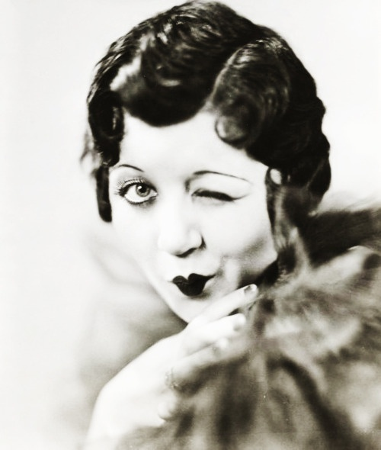 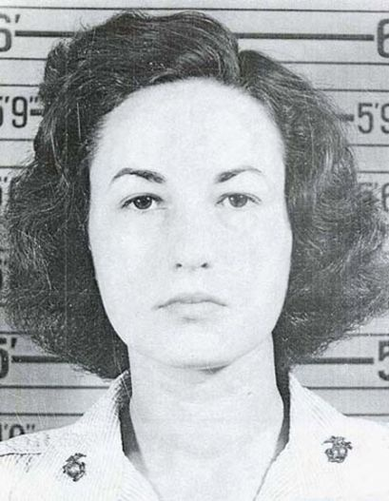

Mae Questel ca. 1930s, the voice of Betty Boop and Bea Arthur (née Bernice Frankel) (1922-2009) Olive Oyl, Minnie Mouse,Felix the Cat (for three SSgt. USMC 1943-45 WW II. Enlisted and shorts by the Van Beuren Studios), Little Lulu, Little assigned as typist at Marine HQ in Wash DC, then Audrey and Casper, the Friendly Ghost air stations in VA and NC. Best remembered for her title role in the TV series Maude and as Dorothy in "Golden Girls".

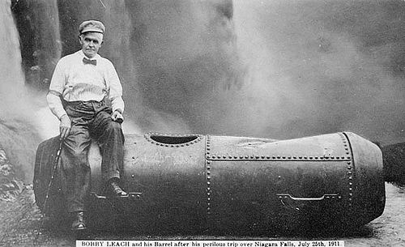 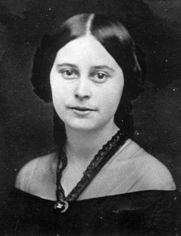

In 1911, Bobby Leach survived a plunge over Niagara Emily Todd was Mary Todd Lincoln's half- Falls in a steel barrel. Fourteen years later in New sister. In 1856 she married Benjamin Helm, Zealand he slipped on an orange peel and died. a Confederate general. After Helm's death in 1863 Emily Helm passed through Union Lines to visit her sister in the White House. This caused great consternation in the Northern newspapers. Emily Helm took an oath of loyalty to the Union and was granted amnesty.

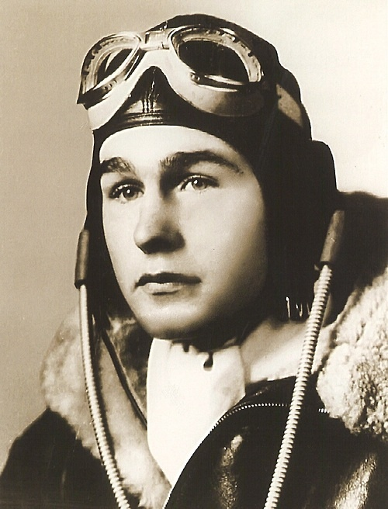 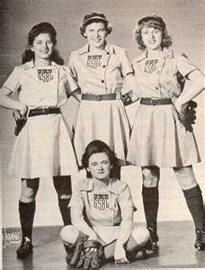

Three days before his 19th birthday, George H.W. All-American Girls Baseball, 1940s

Bush became the youngest aviator in the US Navy.

[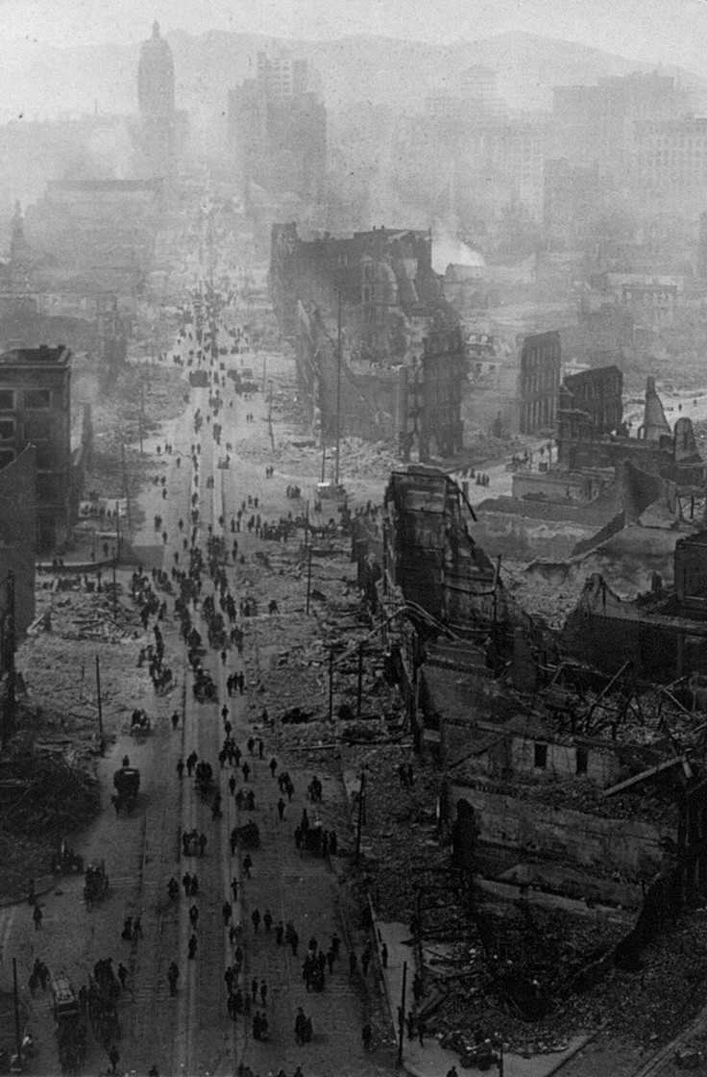](http://i.imgur.com/txCibKt.jpg) 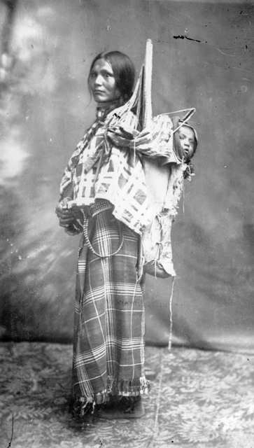

Market Street, San Francisco after the earthquake. Sacajawea. Stolen, held captive, sold

1906 eventually reunited the Shoshone Indians. She was an interpreter and guide for Lewis and Clark in 1805-1806 with her husband Toussaint Charbonneau. She navigated carrying her son, Jean Baptiste, on her back. She traveled thousands of miles from the Dakotas the Pacific Ocean. The explorers, said she was cheerful, never complained, and proved to be invaluable. She served as an advisor, caretaker, and is legendary for her perseverance and resourcefulness

[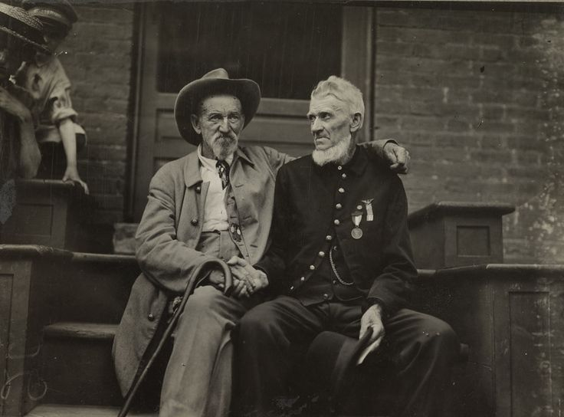](http://i.imgur.com/kt3Pwvz.jpg)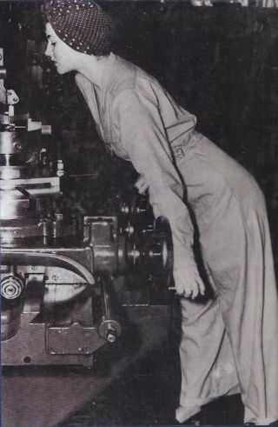

A Confederate and Union soldier shake hands during a Geraldine Doyle, who was the celebration at Gettysburg in 1913. Image from the Library inspiration behind the famous

of Congress. July1-3, 2013 marks the 150th Anniversary Rosie the Riveter poster.

of the Battle of Gettysburg.

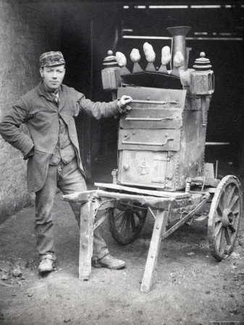 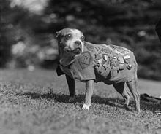

Vintage Baked Potato Cart. A Sergeant Stubby (1916 or 1917 April 4, 1926), was the most legitimate fast food lunch option decoratedwar dog of World War I and the only dog to be promoted to sergeant back in the day through combat. America's first war dog, Stubby, served 18 months 'over there' and participated in seventeen battles on the Western Front. He saved his regiment from surprise mustard gas attacks, found and comforted the wounded, and even once caught a German spy by the seat of his pants holding him there til American Soldiers found him).

[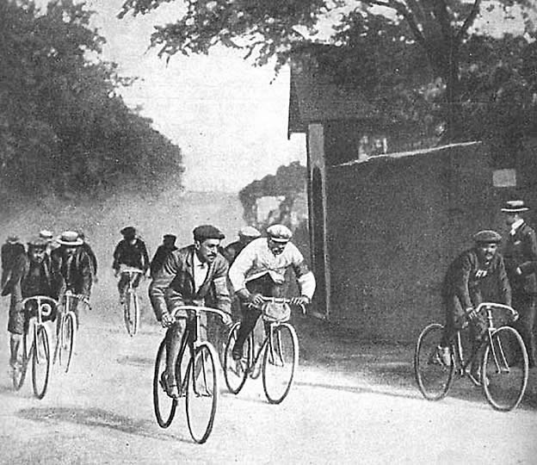](http://i.imgur.com/S3kVMQq.jpg)

Cyclists ride in the first running of the Tour de France, in 1903.

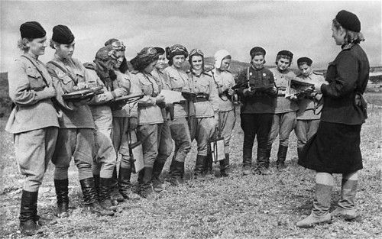

Nightwitches - Female Russian bombers who bombed Germany during WW2.

They had old, noisy planes & the engines used to conk out halfway through their missions, so they had to climb out on the wings mid-flight to restart the props.

To stop Germans from hearing them & starting up the anti aircraft guns, theyd climb

to a certain height, coast down to German positions, drop their bombs, restart their engines in midair & get the hell out of dodge. Their leader flew 200+ missions & was never captured.

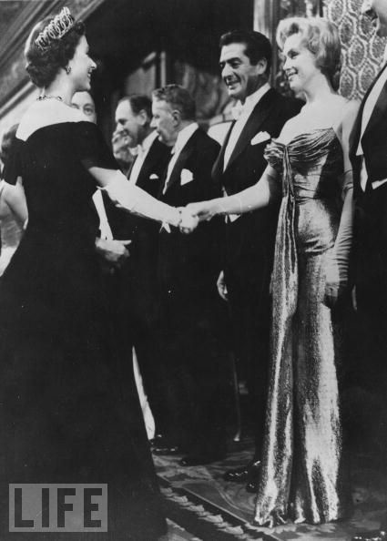 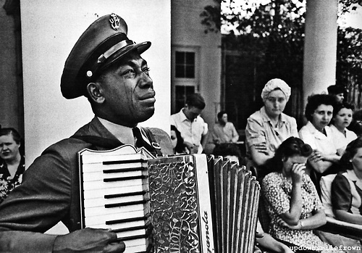

Marilyn Monroe meets Queen Elizabeth II, London, Chief Petty Officer Graham Jackson plays 1956 Both women are 30 years old. Going Home as FDRs body is borne past in Warm Springs, GA, where the President was scheduled to attend a barbecue on the day he died. April, 1945.

[***Click Here for fantastic bird’s eye view of places!***](http://www.buzzfeed.com/lyapalater/27-incredible-views-youd-only-see-if-you-were-a-bird)

***Poem about Aging***

**Another year has passed**

**And we're all a little older.**

**Last summer felt hotter**

**And winter seems much colder.**

**There was a time not long ago**

**When life was quite a blast.**

**Now I fully understand**

**About 'Living in the Past'**

**We used to go to weddings,**

**Football games and lunches..**

**Now we go to funeral homes**

**And after-funeral brunches.**

**We used to have hangovers,**

**From parties that were gay.**

**Now we suffer body aches**

**And wile the night away.**

**We used to go out dining,**

**And couldn't get our fill.**

**Now we ask for doggie bags,**

**Come home and take a pill.**

**We used to often travel**

**To places near and far.**

**Now we get sore asses**

**From riding in the car.**

**We used to go to nightclubs**

**And drink a little booze.**

**Now we stay home at night**

**And watch the evening news.**

**That, my friend is how life is,**

**And now my tale is told.**

**So, enjoy each day and live it up...**

**Before you're too damned old!**

***Senior’s Texting Dictionary***

\***ATD** - At the doctor's  
   
\***BFF** -  Best friends funeral  
   
\***BTW** - Bring the Wheelchair  
   
\***BYOT** - Bring Your Own Teeth  
   
\***CBM** - Covered by Medicare  
   
\***CUATSC -**See You at the Senior Center  
   
\***DWI** - Driving While Incontinent  
   
\***FWIW** - Forgot Where I Was  
   
 **\*GGPBL -** Gotta Go, Pacemaker Battery Low  
   
\***GHA** -  Got Heartburn Again  
   
\***HGBM** - Had Good Bowel Movement  
   
**\*LMDO -** Laughing My Dentures Out  
   
\***LOL** - Living on Lipitor  
   
\***OMSG** - Oh My! Sorry, Gas  
   
\***TOT** - Texting on Toilet  
   
\***WAITT** - Who Am I Talking To?

**\*GGLKI** (Gotta Go, Laxative Kicking In)

***Comedy Section***

***Stupid Is As Stupid Does!***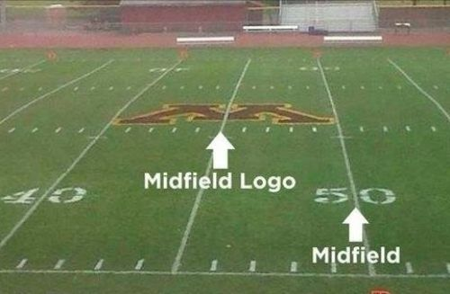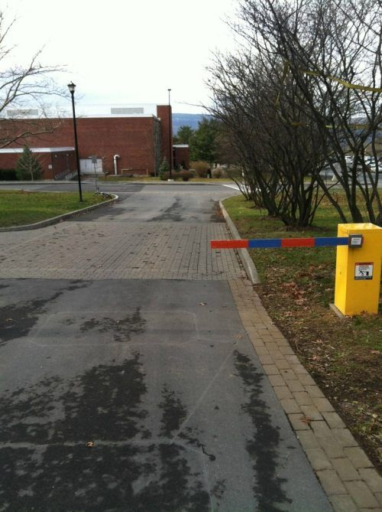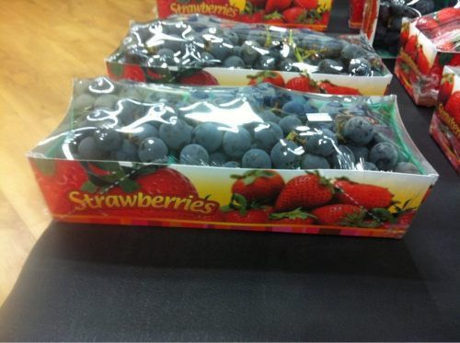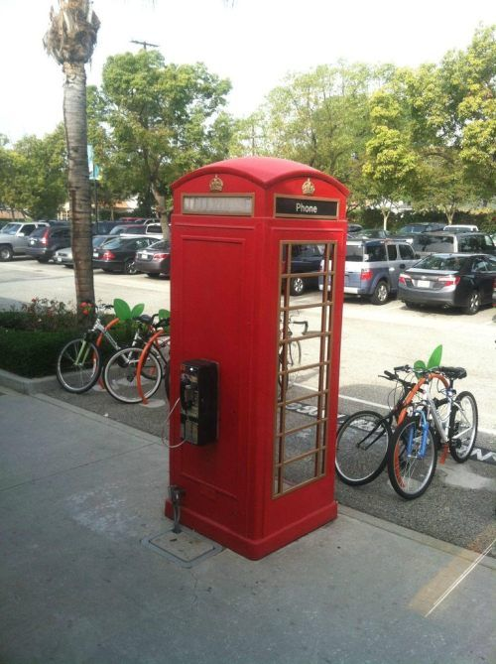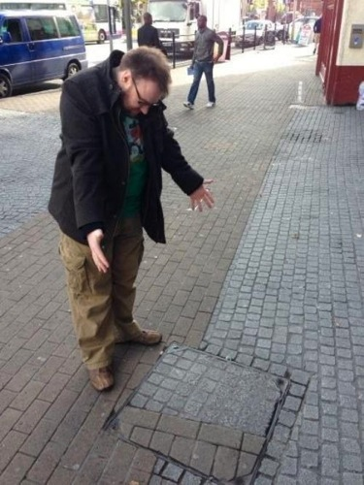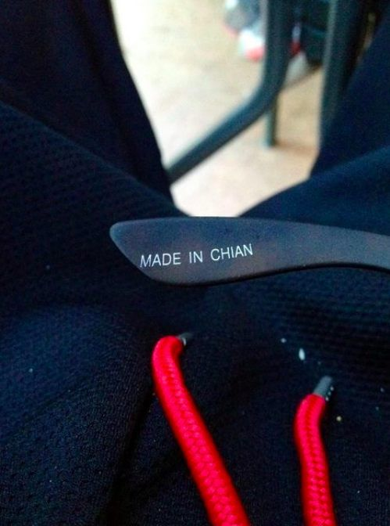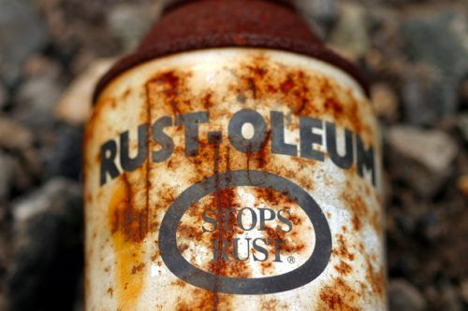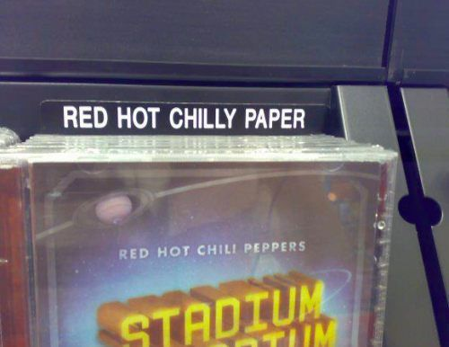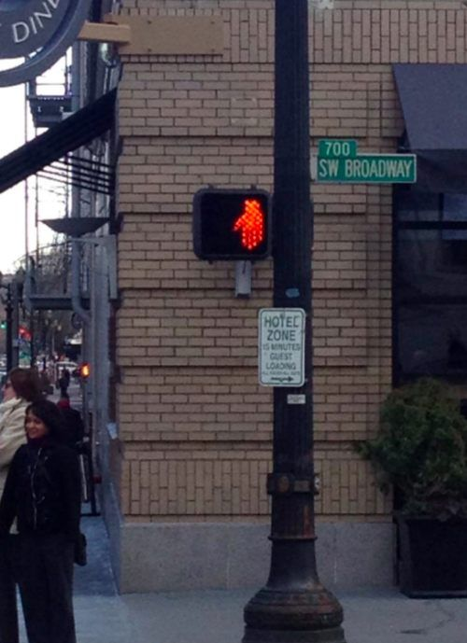

***Araprosdokians***

**Winston Churchill loved araprosdokians, figures of speech in which the latter part of a sentence or phrase is surprising or unexpected.   
   
1. Where there's a will, I want to be in it.  
2. The last thing I want to do is hurt you, but it's still on my list.  
3. Since light travels faster than sound, some people appear bright until you hear them speak.  
4. If I agreed with you, we'd both be wrong.  
5. War does not determine who is right - only who is left.  
6. Knowledge is knowing a tomato is a fruit.  Wisdom is not putting it in a fruit salad.  
7. They begin the evening news with 'Good Evening,' then proceed to tell you why it isn't.  
8. To steal ideas from one person is plagiarism.  To steal from many is research.  
9.  I thought I wanted a career.  Turns out, I just wanted pay checks.  
10. In filling out an application, where it says, 'In case of emergency, notify:'  I put 'DOCTOR."  
11. I didn't say it was your fault, I said I was blaming you.  
12. Women will never be equal to men until they can walk down the street with a bald head and a beer gut, and still think they are sexy.  
13. Behind every successful man is his woman.  Behind the fall of a successful man is usually another woman.  
14. A clear conscience is the sign of a fuzzy memory.  
15. You do not need a parachute to skydive.  You only need a parachute to skydive twice.  
16. Money can't buy happiness, but it sure makes misery easier to live with.  
17. There's a fine line between cuddling and holding someone down so they can't get away.  
18. I used to be indecisive.  Now I'm not so sure.  
19. You're never too old to learn something stupid.  
20. To be sure of hitting the target, shoot first and call whatever you hit the target.  
21. Nostalgia isn't what it used to be.  
22. Change is inevitable, except from a vending machine.  
23. Going to church doesn't make you a Christian any more than standing in a garage makes you a car.  
  
Finally:  
I'm supposed to respect my elders, but nowadays it's getting harder and harder for me to find one.**

***60th High School Reunion***

**He was a widower and she a widow.**

**They had known each other for a number of years being high school classmates and having attended class reunions in the past without fail.**

**This 60th anniversary of their class, the widower and the widow made a foursome with two other singles.**

**They had a wonderful evening, their spirits high.**

**The widower throwing admiring glances across the table. The widow smiling coyly back at him.**

**Finally, he picked up courage to ask her, "Will you marry me?"**

**After about six seconds of careful consideration, she answered,**

**"Yes,..... yes I will!"**

**The evening ended on a happy note for the widower. But the next morning he was troubled.**

**Did she say “Yes” or did she say “No?”**

**He couldn't remember. Try as he would, he just could not recall. He went over the conversation of the previous evening, but his mind was blank.**

**He remembered asking the question but for the life of him could not recall her response. With fear and trepidation he picked up the phone and called her.**

**First, he explained that he couldn't remember as well as he used to. Then he reviewed the past evening.  
As he gained a little more courage he then inquired of her. "When I asked if you would marry me, did you say “Yes” or did you say “No?”**

**"Why you silly man, I said ‘Yes. Yes I will.’ And I meant it with all my heart."**

**The widower was delighted. He felt his heart skip a beat.**

**Then she continued. "And I am so glad you called because I couldn't remember who asked me!”**